THE CORPORATION OF THE MUNICIPALITY OF CALVIN
NOTICE OF PUBLIC MEETING CONCERNING
PROPOSED ZONING BY-LAW AMENDMENT (ZBA-3-2024)
PROPERTY OWNER(S): BOILEAU, CHRISTOPHER & LAURIE
CON 2 LOT 10 PCL 28693 & PCL 25167
Township of Calvin
56 Stewarts Road
TAKE NOTICE that the Council of the Corporation of the Municipality of Calvin will hold a public meeting on the 30th day of April, 2024, at 6:00pm to amend the Township of Calvin Zoning By-Law No. 2022-019, as amended.
The Council of the Corporation of the Municipality of Calvin is undergoing a housekeeping amendment to the Township of Calvin Zoning By-Law No. 2022-019, as amended. The purpose of this amendment is to ensure that properties without access to a year-round maintained public street are zoned accordingly. The property described above is currently zoned Rural (R) and is proposed to be re-zoned to Limited Services Rural (LSR). The LSR zone recognizes properties that do not have access to a year-round maintained public street and reflects that municipal services which may normally be provided will not be guaranteed including, but not limited to, snow ploughing, road upgrading, school bussing, garbage pick-up and/or access by emergency vehicles.

The proposed Zoning By-law Amendment public meeting required under Section 34 of the Planning Act will take place at the Township’s Council Chambers at 1355 Peddlers Drive Mattawa, ON P0H 1V0.
ANY PERSON may attend the public meeting(s) and/or make written or verbal representation either in support of or in opposition to the proposed amendments.
If a person or public body would otherwise have an ability to appeal the decision of the Corporation of the Municipality of Calvin to the Ontario Land Tribunal but the person or public body does not make oral submissions at a public meeting, or make written submissions to the Corporation of the Municipality of Calvin before the by-law is passed, the person or public body is not entitled to appeal the decision.
If a person or public body does not make oral submissions at a public meeting, or make written submissions to the Corporation of the Municipality of Calvin before the by-law is passed, the person or public body is not entitled to appeal the decision of the Council of the Corporation of the Municipality of Calvin to the Ontario Land Tribunal.
If a person or public body does not make oral submissions at a public meeting, or make written submissions to the Corporation of the Municipality of Calvin before the by-law is passed, the person or public body may not be added as a party to the hearing of an appeal before the Ontario Land Tribunal unless, in the opinion of the Tribunal, there are reasonable grounds to do so.
PUBLIC HEARING – You are entitled to participate in the public hearing on your own or you may be represented by counsel or an agent to give evidence about this application. Written submissions that relate to an application shall be accepted by the Clerk before the hearing of the application and shall be made available electronically to any interested person for inspection the day of the hearing by contacting the Clerk during regular office hours.
FOR MORE INFORMATION about this matter, including information about appeal rights, contact Donna Maitland at cao@calvintownship.ca or 1355 Peddlers Drive Mattawa, ON P0H 1V0 or 705-744-2700. If you wish to be notified of the decision of the Council for the Corporation of the Municipality of Calvin on the proposed Zoning By-law amendment, you must make a written request to Donna Maitland at cao@calvintownship.ca or 1355 Peddlers Drive Mattawa, ON P0H 1V0.

Schedule A: Proposed Zoning

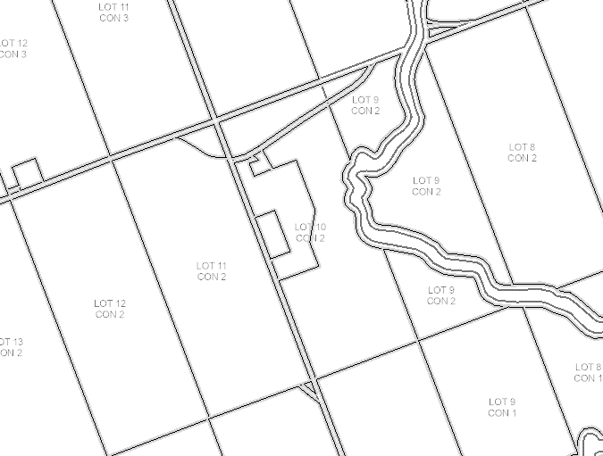
LANDS PROPOSED TO BE RE-ZONED FROM RURAL (R) TO LIMITED SERVICES RURAL (LSR)

